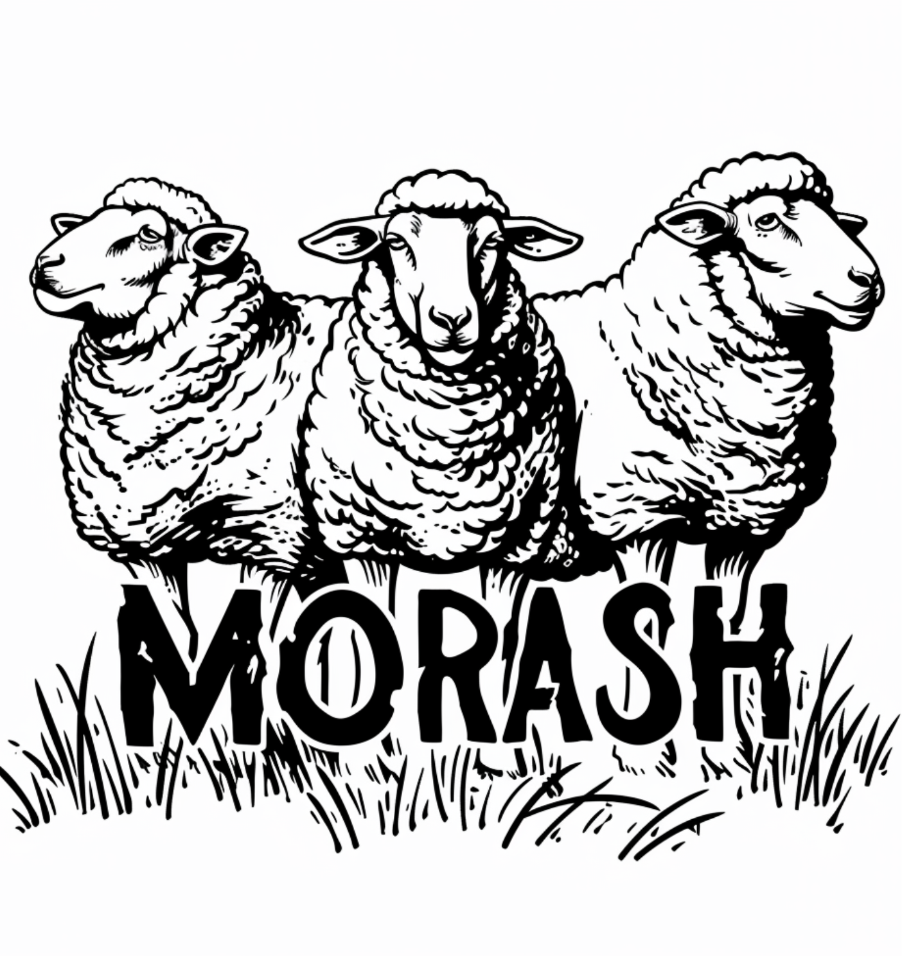

MORASH
SHEEPDOG TRIAL

July 13-14, 2024

Mount Hanley Farm
2645 Clarence Road
Lawrencetown, Nova Scotia B0S 1M0

Entries Open:
May 1, 2024

Entries Close:
June 15, 2024
(or when trial is full)

EMAIL ENTRY ONLY to
ashleycrocker@hotmail.com

Judge:

Anne Hamilton
Nova Scotia

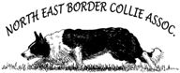

NEBCA Sanctioned

SCHEDULE OF TRIAL
(held under NEBCA Rules & Regulations)

CLASSES:

Ranch
Pro-Novice
Novice-Novice
Beginner (non-sanctioned)

Limited Entry Trial
3 dog limit per handler

Trial Manager/Secretary:
Ashley Crocker
ashleycrocker@hotmail.com

Briefing: 8:30am
Handler’s Meeting: 8:45am
First Class: 9:00am

Canadian Entries - E-transfers only to ashleycrocker@hotmail.com

US Entries - Mail cheques to:
Ashley Crocker
1732 Meadowvale Road
Harmony, Nova Scotia, Canada B0P 1R0

Entry Information  All classes $70 CDN / $65 USD per day (2 runs/day). Entries are limited - maximum of 3 dogs per handler.  Entries open May 1, 2024, and close June 15, 2024.  NO REFUNDS AFTER THE CLOSING DATE.  Payment must be received by the closing date.  Local Food & Shopping  Middleton (10 minutes) – NSLC, Independent, Foodland, Robin’s, Tim Horton’s, Subway, pizza shops, gas stations.  Lawrencetown (5 minutes) – Bee’s Knees General Store and Bakery, Ebb Tide Café  Bridgetown (10 minutes) – Pearles’ in Paradise, Aroma Mocha Café, Tim Horton’s, Graves’ Fresh Mart  Camping/RV  Trial site can accommodate campers, RV’s and dry camping. There is a washroom on site in the shop.  *If you plan to arrive Friday evening with an RV or camper, please message Morgan at 902-840-1276 to indicate what time you will be arriving.  Lodging & Accommodation  There are motels nearby in Middleton, 10 minutes away. Middleton Motel & Suites and Fundy Spray Motel.  Tentative Event Schedule & Classes  Saturday  Ranch 1  Pro-Novice 1  Novice-Novice 1  Beginner 1  Ranch 2  Pro-Novice 2  Novice-Novice 2  Beginner 2  Sunday  Ranch 3  Pro-Novice 3  Novice-Novice 3  Beginner 3  Ranch 4  Pro-Novice 4  Novice-Novice 4  Beginner 4 | Event Timetable for Saturday and Sunday  General Briefing at 8:30am  Handler’s Meeting at 8:45am  First class at 9:00am  Volunteering  Please volunteer to help and sign up on the entry form!  Beginner Class  A non-sanctioned beginner class will be offered to help grow the sport of herding in our area. Handlers may leave the post for the outrun in this class. Dogs that run in the beginner class may not run in any of the NEBCA sanctioned classes at the trial. This class is meant for new handlers, but if space allows, seasoned handlers with young dogs may enter this class as trial environment exposure.  Directions to the Trial Site  2645 Clarence Road, Lawrencetown, NS B0S 1M0  Take Exit 19, Lawrencetown. Go North off the ramp and drive to the end of Elliott Road. Turn left onto Clarence Road at the stop sign and drive 3 kilometers. The farm is on the right side of the road after the church.  Google Maps Link:  https://maps.app.goo.gl/GxRffudQXLmTWvbe8  Trial Site Information  Please pick up after your dog and use the garbage bins available on site. All dogs must be under control (penned, crated, or leashed) when not running. A water pool / hose will be made available to cool your dog off.  Sheep  Mixed flock of dogged and lightly dogged sheep. Some lambs may be used.  Prizes and Awards  Ranch class – payout and ribbons (1st to 4th)  All other classes – prizes and ribbons (1st to 4th)  Overall Awards – Champion and Reserve Champion awards for each division (Ranch, Pro-Novice, Novice-Novice and Beginner)  Judge’s Choice Awards  Questions?  Regarding Entries to this show, please contact Trial Manager, Ashley Crocker at ashleycrocker@hotmail.com

Entry Form
MORASH SHEEPDOG TRIAL
July 13-14, 2024

ONLY EMAIL ENTRIES ARE ACCEPTED

Entries Close: Wednesday June 15, 2024

Handler:
Address:
City: State/Province:

Zip/ Post Code: Country:
Email: Phone:

Mail Entries with Fees to: PLEASE INSERT NAME & ADDRESS HERE

DOG’S NAME | CLASS | # OF RUNS | TOTAL
E-transfer to: ashleycrocker@hotmail.com |  |  | $

WE NEED VOLUNTEERS FOR THE FOLLOWING:
Setout ____ Scribe ____ Exhaust ____ Setout Pen ____ Post/Tally Scores ____

Entry is not valid unless the agreement is read and signed.
I certify that I am the owner of the dog, or that I am the duly authorized agent of the actual owner of the dog and that the dog is not a hazard to persons, property or other dogs. I understand and agree that my entry may be refused for any reason that it deems to be sufficient.
I understand and acknowledge that participation in this event carries certain risks, including, but not limited to injuries (including serious injuries and death) to myself, the dog, another dog under my control or persons attending as my guests, damage to property or other losses. I waive any and all claims that I have or may have in the future against, and release from all liability and agree not to sue Ashley Crocker or the owners of the facility (Morgan Bezanson, Kyle Chute, Mount Hanley Farm) for any injury, death, property damage or other loss that I or my guests sustain due to any cause of negligence, breach of contract, breach of duty, statutory or otherwise, or mistakes or errors of judgment.
Full responsibility for the conduct of myself and my Related Parties during the entirety of the Event is assumed by myself. I agree to indemnify and save harmless the organizers and property owners of this event from and against any and all claims that may be made against them or costs, fees, expenses or liability (including, without limitation, lawyers' fees on a solicitor and own client basis) incurred by that may arise due to: any act or omission of myself, my Related Parties or any party for whom I am liable at law; or aggressive behavior by the Dog or any other dog under my control. I accept liability for any cost incurred as a result of damages caused by me and/or my dog(s) to the facilities, sheep, other livestock, dog(s) or persons. Replacement cost of stock is $500.00 per sheep and/or vet bills.
I have read, understand and agree to abide by the rules set forth in this document, as well as told at the event’s briefing.

Dog Entry Form
Signature of Handler: Date:

Show NAME

